CLASS ACTIVITY 2: PYTHON CODING

SHABARISH N

192424007

Task 1 – CSV File: Student Marks Record Problem Statement
Develop a Python program to collect the details of 10 students and store them in a CSV file named student_marks.csv.
The file should contain:
- Register Number
- Student Name
- Department
- Python Marks
- Data Science Marks

Program:
import csv

with open("student_marks.csv", "w", newline="") as file:
writer = csv.writer(file)

writer.writerow(["Register Number", "Student Name", "Department", "Python Marks", "Data Science Marks"])

for i in range(10):
reg = input("Register Number: ")
name = input("Student Name: ")
dept = input("Department: ")
python_marks = input("Python Marks: ")
ds_marks = input("Data Science Marks: ")

writer.writerow([reg, name, dept, python_marks, ds_marks])

print("Student details saved in student_marks.csv")
Output:

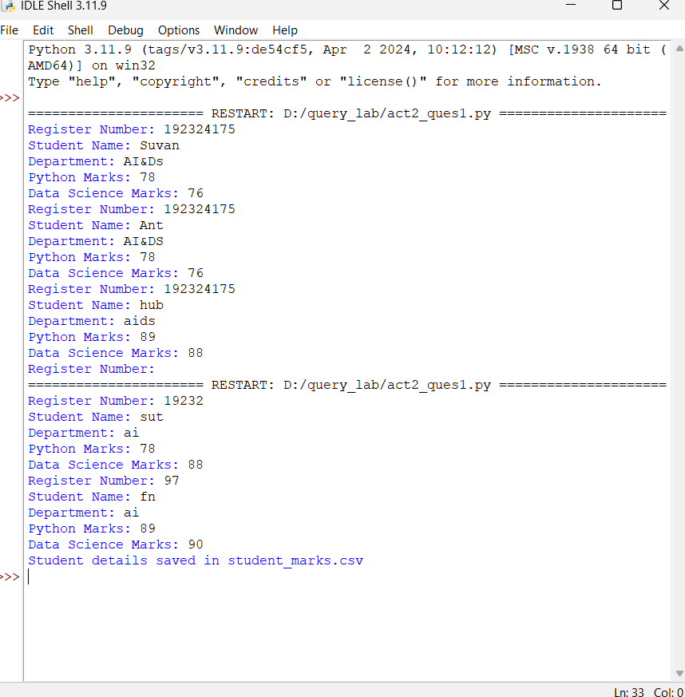

Task 2 – CSV File: Employee Database Problem Statement
Develop a Python program to collect employee information and store it in a CSV file named employees.csv.
The file should contain:
- Employee ID
- Employee Name
- Department
- Designation
- Salary
Store details of at least 5 employees.
Program:
import csv

with open("employees.csv", "w", newline="") as file:
writer = csv.writer(file)

writer.writerow(["Employee ID", "Employee Name", "Department", "Designation", "Salary"])

for i in range(5):
emp_id = input("Employee ID: ")
name = input("Employee Name: ")
dept = input("Department: ")
designation = input("Designation: ")
salary = input("Salary: ")

writer.writerow([emp_id, name, dept, designation, salary])

print("Employee details saved in employees.csv")

Output:
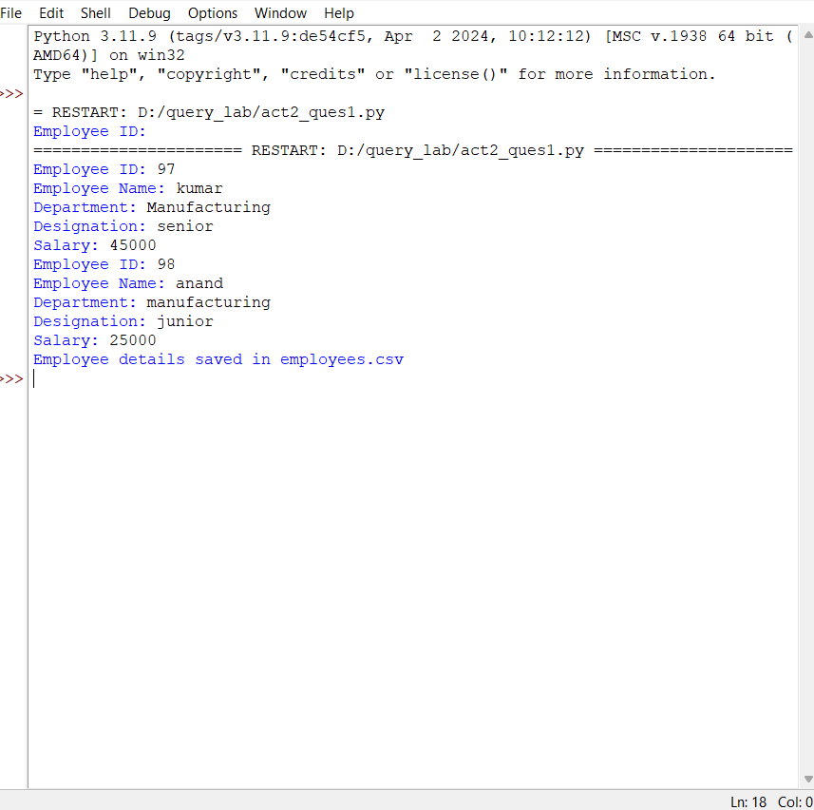

Task 3 – JSON File: Faculty Information System Problem Statement
Create a Python program to collect faculty details and store them in a JSON file named faculty.json.
Each faculty record should contain:
- Faculty ID
- Faculty Name
- Department
- Designation
- Experience (Years)
Store details of at least 5 faculty members.

Program:

import json

faculty_list = []

for i in range(5):
faculty = {
"Faculty ID": input("Faculty ID: "),
"Faculty Name": input("Faculty Name: "),
"Department": input("Department: "),
"Designation": input("Designation: "),
"Experience": input("Experience (Years): ")
}

faculty_list.append(faculty)

with open("faculty.json", "w") as file:
json.dump(faculty_list, file, indent=4)

print("Faculty details saved in faculty.json")

Output:

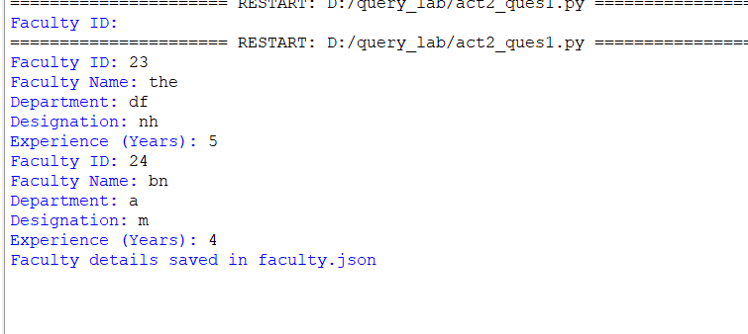

Task 4 – JSON File: Product Inventory Management Problem Statement
Develop a Python program to collect product information and store it in a JSON file named products.json.
Each product should contain:
- Product ID
- Product Name
- Category
- Price
- Quantity Available
Store details of at least 10 products.
Porgram:
import json

products = []

for i in range(1):
product = {
"Product ID": input("Product ID: "),
"Product Name": input("Product Name: "),
"Category": input("Category: "),
"Price": input("Price: "),
"Quantity Available": input("Quantity Available: ")
}

products.append(product)

with open("products.json", "w") as file:
json.dump(products, file, indent=4)

print("Product details saved in products.json")
Output:
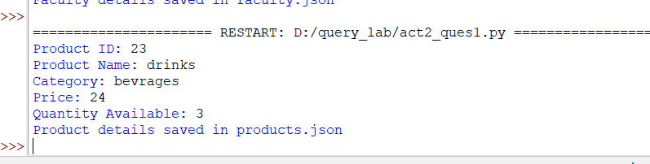

Task 5 – XML File: Course Information Database Problem Statement
Create a Python program to collect course details and store them in an XML file named courses.xml.
Each course should contain:
- Course Code
- Course Name
- Credits
- Department
- Faculty Name
Store details of at least 5 courses.
Program:
import xml.etree.ElementTree as ET

root = ET.Element("Courses")

for i in range(1):
course = ET.SubElement(root, "Course")

ET.SubElement(course, "CourseCode").text = input("Course Code: ")
ET.SubElement(course, "CourseName").text = input("Course Name: ")
ET.SubElement(course, "Credits").text = input("Credits: ")
ET.SubElement(course, "Department").text = input("Department: ")
ET.SubElement(course, "FacultyName").text = input("Faculty Name: ")

tree = ET.ElementTree(root)
tree.write("courses.xml")

print("Course details saved in courses.xml")

Output:
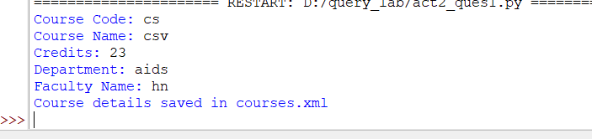

Task 6 – XML File: Hospital Patient Management System Problem Statement
Develop a Python program to collect patient information and store it in an XML file named patients.xml.
Each patient record should contain:
- Patient ID
- Patient Name
- Age
- Disease
- Doctor Assigned
Store details of at least 10 patients.

Program:

import xml.etree.ElementTree as ET

root = ET.Element("Patients")

for i in range(10):

patient = ET.SubElement(root, "Patient")

ET.SubElement(patient, "PatientID").text = input("Patient ID: ")

ET.SubElement(patient, "PatientName").text = input("Patient Name: ")

ET.SubElement(patient, "Age").text = input("Age: ")

ET.SubElement(patient, "Disease").text = input("Disease: ")

ET.SubElement(patient, "DoctorAssigned").text = input("Doctor Assigned: ")

tree = ET.ElementTree(root)

tree.write("patients.xml")

print("Patient details saved in patients.xml")

Output:

